**Lab 5**: Perform a CRUD operation having fields first name, last name, gender, class, batch, and roll number.

Source Code

**//conn.php**

<?php

$con = mysqli_connect('localhost','root');

mysqli_select_db($con,'weblab');

?>

**//insert.php**

<?php

if(isset($_POST['done'])){

$con = mysqli_connect('localhost','root');

mysqli_select_db($con,'weblab');

$firstname = $_POST['firstname'];

$lastname = $_POST['lastname'];

$roll_no = $_POST['roll_no'];

$class = $_POST['class'];

$batch = $_POST['batch'];

$gender = $_POST['gender'];

$q = "INSERT INTO users (firstname,lastname,rollno,class,batch,gender) VALUES ('$firstname','$lastname','$roll_no','$class','$batch','$gender')";

if ($con->query($q) === TRUE) {

echo "New record created successfully";

header('location:display.php');

} else {

echo "Error: " . $q . "<br>" . $con->error;

}

}

?>

<!DOCTYPE html>

<html>

<head>

<title></title>

<meta name="viewport" content="width=device-width, initial-scale=1">

<link rel="stylesheet" href="https://maxcdn.bootstrapcdn.com/bootstrap/4.0.0/css/bootstrap.min.css">

<script src="https://ajax.googleapis.com/ajax/libs/jquery/3.3.1/jquery.min.js"></script>

<script src="https://cdnjs.cloudflare.com/ajax/libs/popper.js/1.12.9/umd/popper.min.js"></script>

<script src="https://maxcdn.bootstrapcdn.com/bootstrap/4.0.0/js/bootstrap.min.js"></script>

</head>

<body>

<div class="col-lg-6 m-auto">

<form method="post">

<br><br><div class="card">

<div class="card-header bg-dark">

<h1 class="text-white text-center"> Add Students </h1>

</div><br>

<label> FirstName: </label>

<input type="text" name="firstname" class="form-control"> <br>

<label> LastName: </label>

<input type="text" name="lastname" class="form-control"> <br>

<label> Roll Number: </label>

<input type="number" name="roll_no" class="form-control"> <br>

<label> Class: </label>

<select class="form-control" name="class">

<option selected disabled>Select A Class</option>

<option value="One">One</option>

<option value="Two">Two</option>

<option value="Three">Three</option>

<option value="Four">Four</option>

<option value="Five">Five</option>

</select>

<label> Batch: </label>

<select class="form-control" name="batch">

<option selected disabled>Select A Batch</option>

<option value="2071">2071</option>

<option value="2072">2072</option>

<option value="2073">2073</option>

<option value="2074">2074</option>

<option value="2075">2075</option>

<option value="2076">2076</option>

<option value="2077">2077</option>

</select>

<label> Gender: </label>

<div class="form-control">

<input type="radio" name="gender" value="male" checked>Male

<input type="radio" name="gender" value="female">Female

</div>

<br>

<button class="btn btn-success" type="submit" name="done"> Submit </button><br>

</div>

</form>

</div>

</body>

</html>

**//display.php**

<!DOCTYPE html>

<html>

<head>

<title></title>

<meta name="viewport" content="width=device-width, initial-scale=1">

<link rel="stylesheet" href="https://maxcdn.bootstrapcdn.com/bootstrap/4.0.0/css/bootstrap.min.css">

<script src="https://ajax.googleapis.com/ajax/libs/jquery/3.3.1/jquery.min.js"></script>

<script src="https://cdnjs.cloudflare.com/ajax/libs/popper.js/1.12.9/umd/popper.min.js"></script>

<script src="https://maxcdn.bootstrapcdn.com/bootstrap/4.0.0/js/bootstrap.min.js"></script>

<link rel="stylesheet" type="text/css" href="http://ajax.aspnetcdn.com/ajax/jquery.dataTables/1.9.4/css/jquery.dataTables.css">

<script type="text/javascript" charset="utf8" src="https://ajax.aspnetcdn.com/ajax/jquery.dataTables/1.9.4/jquery.dataTables.min.js"></script>

</head>

<body>

<div class="container">

<div class="col-lg-12">

<br><br>

<h1 class="text-warning text-center" > View All Students </h1>

<br>

<button class="btn-success btn"> <a href="insert.php" class="text-white"> Add Students </a> </button>

<table id="tabledata" class=" table table-striped table-hover table-bordered">

<tr class="bg-dark text-white text-center">

<th> Id </th>

<th> FirstName </th>

<th> LastName </th>

<th> Gender </th>

<th> Class </th>

<th> RollNo </th>

<th> Batch </th>

<th> Delete </th>

<th> Update </th>

</tr >

<?php

include 'conn.php';

$q = "select * from users ";

$query = mysqli_query($con,$q);

while($res = mysqli_fetch_array($query)){

?>

<tr class="text-center">

<td> <?php echo $res['id']; ?> </td>

<td> <?php echo $res['firstname']; ?> </td>

<td> <?php echo $res['lastname']; ?> </td>

<td> <?php echo $res['gender']; ?> </td>

<td> <?php echo $res['class']; ?> </td>

<td> <?php echo $res['rollno']; ?> </td>

<td> <?php echo $res['batch']; ?> </td>

<td> <button class="btn-danger btn"> <a href="delete.php?id=<?php echo $res['id']; ?>" class="text-white"> Delete </a> </button> </td>

<td> <button class="btn-primary btn"> <a href="update.php?id=<?php echo $res['id']; ?>" class="text-white"> Update </a> </button> </td>

</tr>

<?php

}

?>

</table>

</div>

</div>

<script type="text/javascript">

$(document).ready(function(){

$('#tabledata').DataTable();

})

</script>

</body>

</html>

**//update.php**

<?php

include 'conn.php';

if(isset($_POST['done'])){

$id = $_GET['id'];

$firstname = $_POST['firstname'];

$lastname = $_POST['lastname'];

$roll_no = $_POST['roll_no'];

$class = $_POST['class'];

$batch = $_POST['batch'];

$gender = $_POST['gender'];

$q = " update users set id=$id, firstname='$firstname', lastname='$lastname', rollno='$roll_no', class='$class', batch='$batch', gender='$gender' where id=$id ";

if ($con->query($q) === TRUE) {

echo " Record updated successfully";

header('location:display.php');

} else {

echo "Error: " . $q . "<br>" . $con->error;

}

header('location:display.php');

}

?>

<!DOCTYPE html>

<html>

<head>

<title></title>

<meta name="viewport" content="width=device-width, initial-scale=1">

<link rel="stylesheet" href="https://maxcdn.bootstrapcdn.com/bootstrap/4.0.0/css/bootstrap.min.css">

<script src="https://ajax.googleapis.com/ajax/libs/jquery/3.3.1/jquery.min.js"></script>

<script src="https://cdnjs.cloudflare.com/ajax/libs/popper.js/1.12.9/umd/popper.min.js"></script>

<script src="https://maxcdn.bootstrapcdn.com/bootstrap/4.0.0/js/bootstrap.min.js"></script>

</head>

<body>

<div class="col-lg-6 m-auto">

<?php

include 'conn.php';

$id = $_GET['id'];

$q = "select * from users where id=$id ";

$query = mysqli_query($con,$q);

while($res = mysqli_fetch_array($query)){

?>

<form method="post">

<br><br><div class="card">

<div class="card-header bg-dark">

<h1 class="text-white text-center"> Update Students </h1>

</div><br>

<label> FirstName: </label>

<input type="text" name="firstname" class="form-control" value="<?php echo $res['firstname']; ?>"> <br>

<label> LastName: </label>

<input type="text" name="lastname" class="form-control" value="<?php echo $res['lastname']; ?>"> <br>

<label> Roll Number: </label>

<input type="number" name="roll_no" class="form-control" value="<?php echo $res['rollno']; ?>"> <br>

<label> Class: </label>

<select class="form-control" name="class">

<option value="<?php echo $res['class']; ?>" selected><?php echo $res['class']; ?></option>

<option value="One">One</option>

<option value="Two">Two</option>

<option value="Three">Three</option>

<option value="Four">Four</option>

<option value="Five">Five</option>

</select>

<label> Batch: </label>

<select class="form-control" name="batch">

<option value="<?php echo $res['batch']; ?>" selected><?php echo $res['batch']; ?></option>

<option value="2071">2071</option>

<option value="2072">2072</option>

<option value="2073">2073</option>

<option value="2074">2074</option>

<option value="2075">2075</option>

<option value="2076">2076</option>

<option value="2077">2077</option>

</select>

<label> Gender: </label>

<div class="form-control">

<input type="radio" name="gender" value="male" <?php echo $res['gender'] == 'male'?'checked':''; ?>>Male

<input type="radio" name="gender" value="female" <?php echo $res['gender'] == 'female'?'checked':''; ?>>Female

</div>

<button class="btn btn-success" type="submit" name="done"> Submit </button><br>

</div>

</form>

<?php

}

?>

</div>

</body>

</html>

**//delete.php**

<?php

include 'conn.php';

$id = $_GET['id'];

$q = " DELETE FROM `users` WHERE id = $id ";

if ($con->query($q) === TRUE) {

echo "Record Deleted Successfully";

header('location:display.php');

} else {

echo "Error: " . $q . "<br>" . $con->error;

}

header('location:display.php');

?>

Output

**Insert**

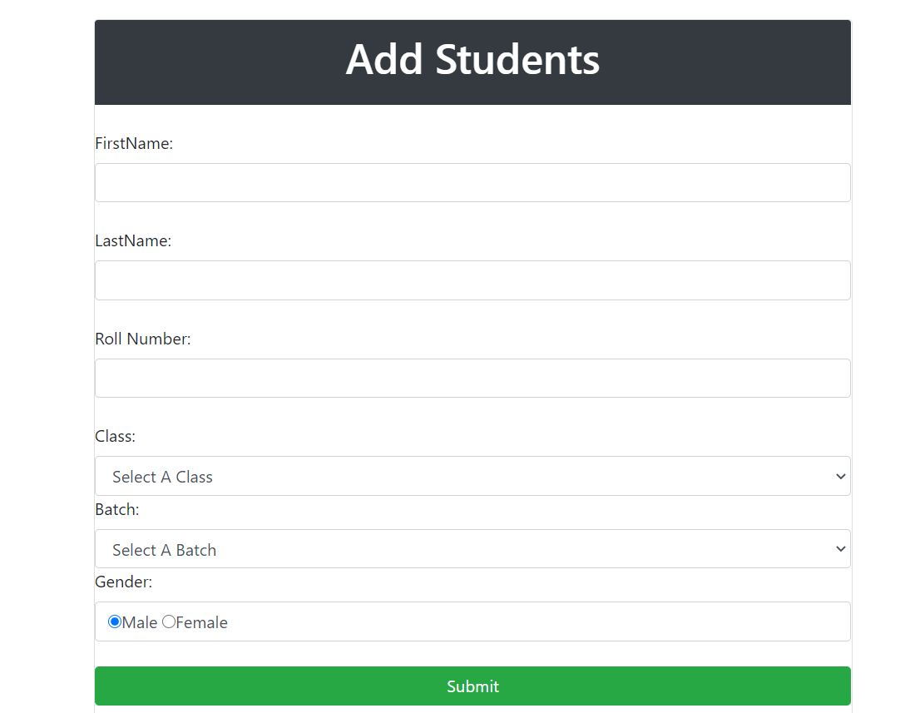

**Display**

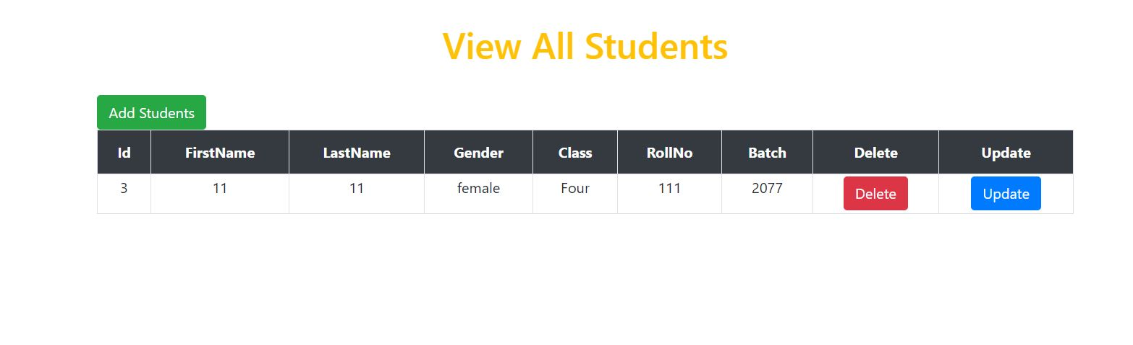

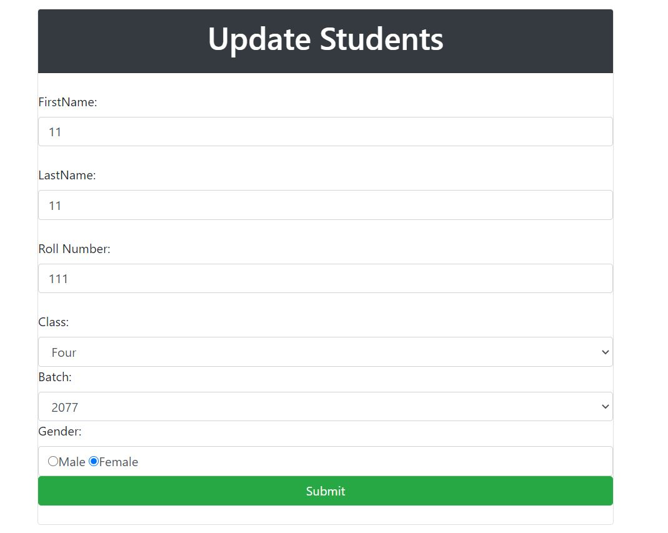**Update**